Africa Map- Part 1- Draw the following physical features on your outlined map of Africa. Make sure they are located in the appropriate spot. Color them according to the feature and label them. Use textbook Atlas.
Physical Features-
- Congo Basin
- Kalahari Desert
- Namib Desert
- Atlantic Ocean
- Indian Ocean

- Great Rift Valley
- Mt. Kilimanjaro
- Lake Victoria
- Congo River

- Sahara Desert
- Sahel
- Niger River
- Nile River

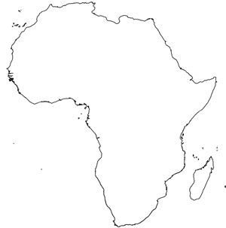
- How do physical features & climates impact where people live in Sub-Saharan Africa? (4 Sentences)

African Kingdoms- Part 2- Label and color in the territory of each kingdom. Create a Key!
- Kingdoms of Africa
- Label Cities
- Timbuktu
- Great Zimbabwe
- Aksum
- Meroë
- Carthage

- Kush
- Aksum
- Ghana
- Mali
- Songhai
- Zimbabwe
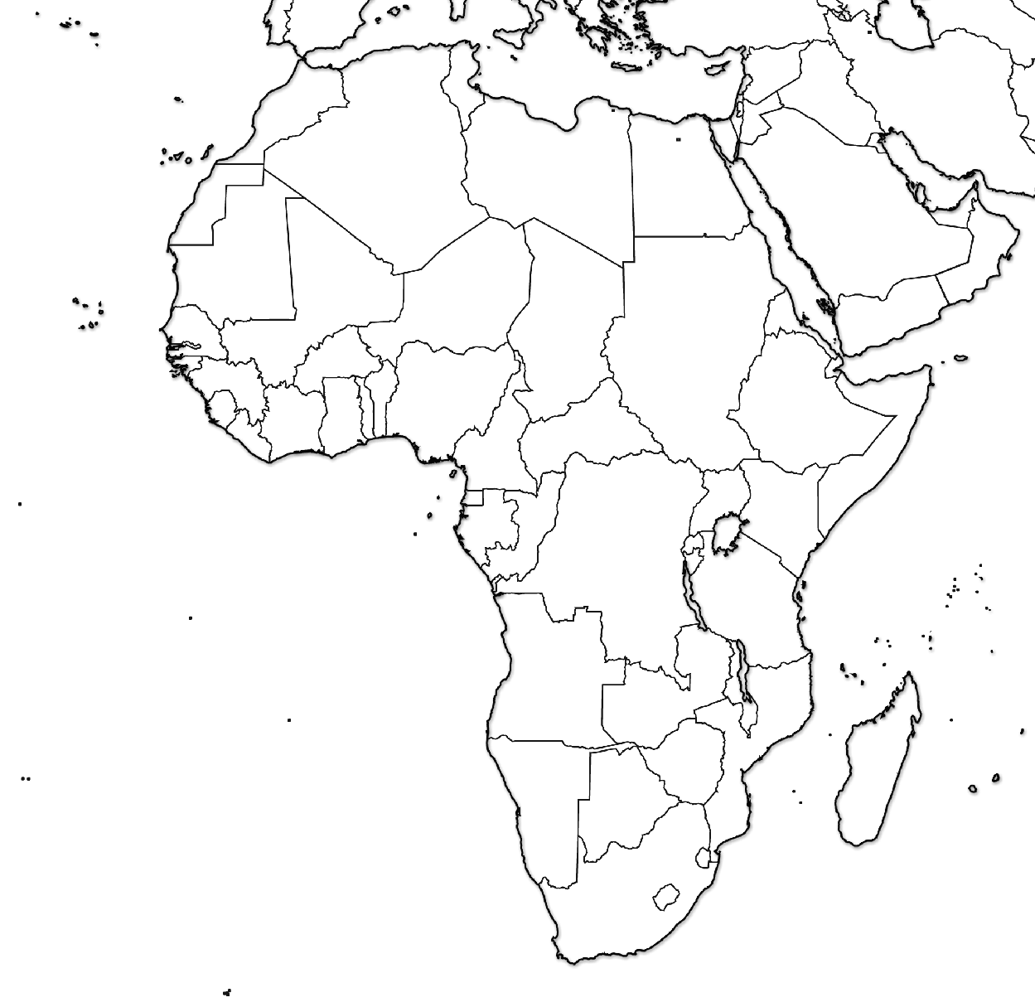
- Explain the effects of migration (3 sentences)

- Explain the causes of migration (3 sentences)

Bantu Migration
Draw the Bantu Migration (arrows). Include a Key in the space below

Africa Reading

Directions: Answer questions in complete thoughts on a separate sheet of paper.
1. Why did European powers call Africa the “Dark Continent”? (No, it’s not because everybody was black…)
2. What is a griot?
3. Where are the Nok from?
4. What “mystery” did the Nok uncover?
5. The Phoenicians are credited with inventing what?
6. Why did the Phoenicians choose Carthage?
7. Who fought in the Punic Wars?
8. Why did the people south of the Sahara have little contact with the rest of the world?
9. What was the most important trade item in West Africa?
10. What were advantages to converting to Islam?
11. Why were rivers important to Ghana?
12. How did Ghana become wealthy?
13. What was Ghana’s power based upon?
14. Who was Sundiata?
15. What does mansa mean?
16. Why did Sundiata convert to Islam?
17. How was Mansa Musa’s faith different than that of Sundiata’s?
18. What is a hajj?
19. How did Mansa Musa affect the economy of Cairo?
20. Which empire rose after the fall of Mali?
21. What was Timbuktu?
22. Why was Timbuktu influential in Mali’s history?

