Imperialism
- Imperialism- Policy of ____________________________ through diplomacy or military force.
- _____________________- of a country or territory by a stronger county.
- Imperialism caused by _____________________________.
- Needs for _________________________ and _____________________ to sell goods.
Forms of Imperial Control
- ___________________- a country or territory governed by a foreign power
- ______________________- a country or territory under the control of an outside power
- ________________________- an area in which an outside power claims exclusive investment or trading rights
- ___________________________- independent, less developed country controlled by private business interests rather than other governments
Imperial Management- Indirect Control
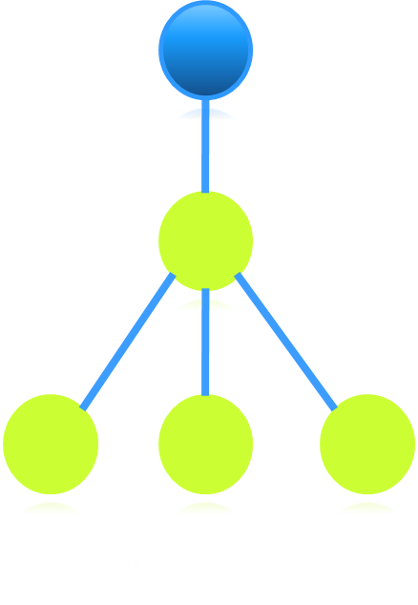
- Relies on existing political rulers
- Local rulers are trained in foreign methods of government
- Local rulers hold government offices
- Goal: To develop future leaders

Imperial Management- Direct Control
Foreign officials hold government offices
No self-rule
_____________________: providing for the needs of the colony without giving them rights
Goal: ________________; adopt European culture
Imperialism in Africa
- ______________________-Hundreds of ethnic groups and languages.
- Berlin Conference of 1884-1885, European nations established rules for the division of Africa; African leaders not invited.
- Causes:
  - __________________
  - __________________
  - __________________- rubber, tin, copper, gold, silver

