What Is the Primary Reason To Study The Byzantines? DBQ
Background Essay
In 323 CE, Constantine, a young Roman military officer, successfully defeated three other generals to become the Emperor of Rome. He quickly made 2 decisions: (1) He gave Christianity legal standing within the empire. (2) He moved the imperial capital from Rome to Byzantium, a small seaside trade town in modern-day Turkey. Why? He wanted to be able to pay closer attention to the challenges from Persia and the Germanic tribes. He also wanted to be nearer to the spiritual and cultural richness of cities like Jerusalem, Nicomedia, and ancient Troy.
Constantine lavishly built-up Byzantium and named it after himself (Constantinople). The city would grow to 500,000 people and in time showcase the Hagia Sophia and other stunning architectural wonders. Constantinople would remain the capital and holy city of the eastern Roman Empire until it's capture by the Turks in 1453.
For whatever reason Byzantine history is often ignored or downplayed in American classrooms. Can you make a case for giving the Byzantines more attention?
Document A
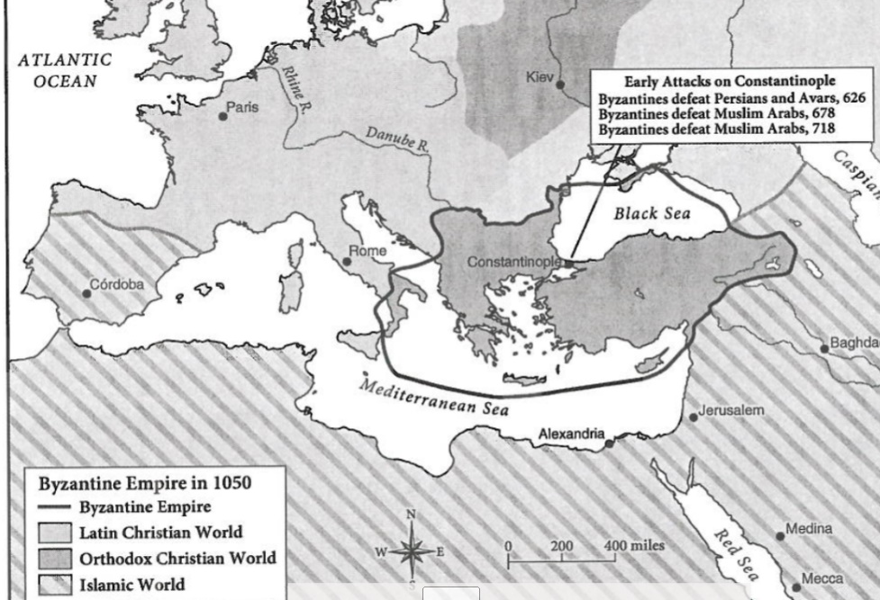
Source: John Julius Norwich, A Short History of Byzantium, Vintage, 1998. Map created from various sources.
“The Byzantines … [withstood] 5 years of siege by [the Arabs] hitherto considered irresistible, and in doing so …saved Western Civilization. Had the [Arabs] captured Constantinople in the 7th century …all Europe – and America – might be Muslim today.”

Document B
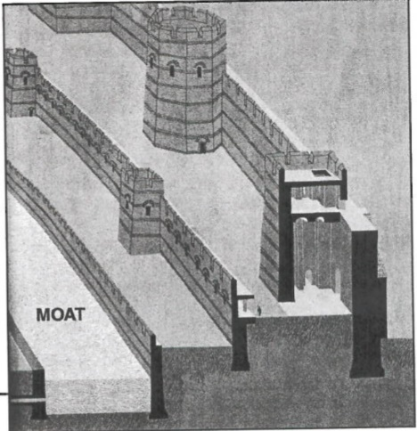
Source: Philip Sherrard, The Great Ages of Man: Byzantium, Time-Life Books, New York, 1966; Drawing courtesy of the David Klein Estate
“The elaborate defense works that surrounded Constantinople made it in its day the best-fortified city in the world... the walls were erected in the 5th century to protect the city against the Goths and the Huns who had captured Rome they served their purpose well, holding off invaders for nearly 1000 years period.. A single wall bound to the city’s seaward sides which were defended by the Byzantine fleet. On the land side, the Byzantine constructed a Moat and three walls that were 25 feet thick. As indicated in the sketch invaders were facing first with the Moat some 60 feet wide and 22 feet deep that was normally dry but could be flooded by pipes. Behind the Moat was a low wall to shield a line of Archers. Even if the attackers could overcome this first wall, they were confronted by a second wall, 27 feet high, which sheltered more troops. Beyond the wall lay the third and strongest bulwark. Its towers some 70 feet high housed more Archers and missile throwers only the force of gunpowder finally demolished the protecting walls bringing Constantinople down.” Note: during the 1100-year history of the Byzantine Empire, 24 efforts were made to capture the city of Constantinople. Only two were successful. The Crusaders entered the city in 1204 but were eventually thrown out a few decades later period the Turkish invasion of 1453 marked the end of the Byzantine Empire.
Document C
Source: Chart Compiled from The World Fact Book, 2011.
Note: in the centuries that followed Emperor Constantine’s move to Byzantium the Christian Church of Rome and the Christian Church of Constantinople grew apart. The final split occurred in 1054 a separation that continues to this day the reason for the split had to do with some spiritual interpretations of the Bible whether or not a priest could get married and the refusal by Constantinople to accept the supreme authority of the Pope.
Eastern Orthodox Christianity Around The World
Nation | Rank in Orthodox Population | Eastern Orthodox Population | % that is Eastern Orthodox
Russia | 1 | 106,445,473 | 75%
Ukraine | 2 | 34,862,521 | 76%
Ethiopia | 3 | 34,461,135 | 44%
Romania | 4 | 18,726,322 | 88%
Greece | 5 | 11,080,059 | 98%
United States | 11 | 5,269,864 | 2%

Document D
Note: Justinian ruled the Byzantine empire from 527 to 565 CE. The laws of the Roman Empire were very disorganized and sometimes contradicted each other. Lawyers often took advantage of the confusion by using long-forgotten laws to support their cases. Justinian, therefore, appointed a Commission of 10 experts who created a new code called Justinian’s code. Historians credit Justinian’s code as shaping our basic ideas of law and justice today.
Justinian’s Code,  Justinian’s experts, 531 CE  “Justice is the constant & [continuous] wish to render everyone his due…The [main guidelines] of law are these: to live honestly, to hurt no one, to every one his due.” | The 2nd Treatise of Government,  John Locke, 1690  “The state of nature …teaches all man kind, who will but consult it, that being equal and independent, no one out to harm another in his life, health, liberty, or possessions.” | The Declaration of Independence, Thomas Jefferson, 1776  “We hold these truths to be self-evident, that all men are created equal, that they are endowed by their Creator with certain unalienable rights, that among these are Life, Liberty, and the pursuit of Happiness.”

Document E
Source: Cyril Mango, “The Revival of Learning,” The Oxford History of Byzantium, Oxford University Press, 2002.
The most important achievement of the Byzantine revival lay... In the preservation of a sizable portion of the ancient Greek classics… From the point of view of Western culture it may even be said that this act of salvage constitutes the greatest debt to Byzantium… all the saved classic literature... survived because men in the 9th and 10th centuries... recopied it at the time in minuscule script... it is remarkable how much has survived.
Ancient Greek Literature Preserved by Byzantine Scribes
Homer | The Illiad and The Odyssey are among the most widely read poems in American & European schools & colleges today.
Sophocles | Theatrical plays, including Oedipus Rex, helped to define a form of literature called tragedy
Socrates | Known to us through the writings of Plato and others, Socrates crafted a form of inquiry and debate called the Socratic Method. It features questions rather than answers.
Plato | One of Plato's works, The Republic, describes an ideal society and explores the importance of justice in that society
Aristotle | His many scientific and philosophical writings advanced the use of logic and scientific thought.
Euclid | He made inquiries into astronomy, music, and mathematics. Regarded as the father of geometry.
Hippocrates | His medical works and his ethical standards led to the still-used Hippocratic Oath taken by all doctors.

Reading Questions
Background Essay
- Who was Constantine?
- What 2 decisions did Constantine make that changed European history?
- How long was Constantinople the capital of the Byzantine world?
Document A
- What religion dominated Europe in 1050? What religion dominated Africa & Asia?
- What Christian city was closest to Asian Muslim lands?
- What did John Julius Norwich explain would happen without the Byzantine Empire?
Document B
- Why were the walls of Constantinople built? Why was it so difficult for an attacking enemy to break through?
- Why couldn’t an enemy attack on the seaward side of the city?
- How many attempts were made to take the city? How many were successful?
Document C
- Why did the Eastern Orthodox Church separate from the western Roman Catholic Church?
- Which country has the world’s highest Eastern Orthodox population? Which one has the highest %?
- Does the Patriarch of Constantinople has great power over Russia, Ukraine, and Ethiopia today?
Document D
- According to Justinian’s Code, what are the 3 guidelines for writing laws?
- What did the 2nd Treatise of Government & Justinian’s Code have in common?
- What did The Declaration of Independence & Justinian’s Code have in common?
Document E
- How were the Byzantines able to preserve Greek classics?
- Which Greek thinker from the chart is most influential in American schools? Why?

Example Essay
Hook
What is the Abbasid Dynasty?
Thesis
Topic 1 Sentence
2 facts from the documents that support your topic sentence
Topic 1 Conclusion sentence
Topic 2 Sentence
2 facts from the documents that support your topic sentence
Topic 2 Conclusion sentence

The Abbasid Dynasty may have lost land compared to other dynasties, but did you know they invented early robots? The Abbasid Dynasty was in charge of Dar al-Islam during its “Golden Age”. They made advancements in math, science, art, literature, and medicine. Historians should study the Abbasid Dynasty because their geography set the stage for the Age of Exploration and because they updated ancient knowledge.

The entire world was changed from the Age of Exploration, and it would not have happened if it weren’t for the Abbasid Dynasty. Abbasid citizen Ibn Battuta explored Asia & Africa, which led to more accurate maps for explorers. The Abbasids also updated the Chinese compass and made the astrolabe. Both of these were navigation tools used by explorers.(DOC A) Without maps and ways to navigate, there would be no age of exploration.

The Silk Road & Southern Indian Ocean Trade Network connected the ancient world. But when the Huns invaded, those connections temporarily stopped, especially in Europe. The Abbasid scholars revived the trade and used their connection to update ancient texts. They improved Chinese guns to make cannons. They also improved Greek algebra. (DOC B) And they used science to update medicine. (DOC C) Without the Abbasid Dynasty, this knowledge would have been lost and societies would have had to start over again.

INTRODUCTION
Hook_____________________________________________________________________________________________
__________________________________________________________________________________________________
Background/What was the Byzantine Empire? ___________________________________________________________ ____________________________________________________________________________________________________________________________________________________________________________________________________
Restated Question/Thesis____________________________________________________________________________
__________________________________________________________________________________________________
BODY PARAGRAPH (Reason #1)
Topic Sentence 1____________________________________________________________________________________
First evidence from documents _______________________________________________________________________
______________________________________________________________________________________________________________________________________________________________________ DOCUMENT LETTER:__________
Second evidence from documents _____________________________________________________________________
______________________________________________________________________________________________________________________________________________________________________ DOCUMENT LETTER:__________
Conclusion_____________________________________________________________________________________________________________________________________________________________________________________________________________________________________________________________________________________________
BODY PARAGRAPH (Reason #2)
Topic Sentence 2____________________________________________________________________________________
First evidence from documents _______________________________________________________________________
______________________________________________________________________________________________________________________________________________________________________ DOCUMENT LETTER:__________
Second evidence from documents _____________________________________________________________________
______________________________________________________________________________________________________________________________________________________________________ DOCUMENT LETTER:__________
Conclusion_____________________________________________________________________________________________________________________________________________________________________________________________________________________________________________________________________________________________

