Unit 7 Vocab- Industrial Revolution through WWII.
Key Terms/Events-
Industrial Revolution
Assembly Line
Model T
Urbanization
Mass Production
Interchangeable Parts
Middle Class
Laissez-faire
Western Front
Schleffen Plan
Unrestricted Submarine Warfare
Total War
Armistice
Self Determination
Fascism
Authoritarianism
Totalitarianism
Rape of Nanjing
Blitzkrieg
Annexation
Pearl Harbor
Stalingrad
D-Day/Operation Overlord
Atomic Bomb
V.E. Day
V.J. Day

Key People-
Henry Ford
Thomas Edison
Alexander Bell
Mohandas Gandhi
Benito Mussolini
Adolf Hitler
Hirohito
Albert Einstein
Sigmund Freud
Pablo Picasso
Winston Churchill
Josef Stalin
F.D. Roosevelt
Harry Truman

Label the Following (pg. 979)- Great Britain, France, Italy, Russia, Greece, Serbia, Romania, Belgium, Switzerland, Netherlands, Sweden, Denmark, Albania, Spain, Portugal, Germany, Austria-Hungary, Bulgaria, Ottoman Empire, Atlantic Ocean, North Sea, Baltic Sea, Black Sea. Shade the Allied Countries Purple, Shade the Central Powers Yellow, Shade the Neutral Countries Green.
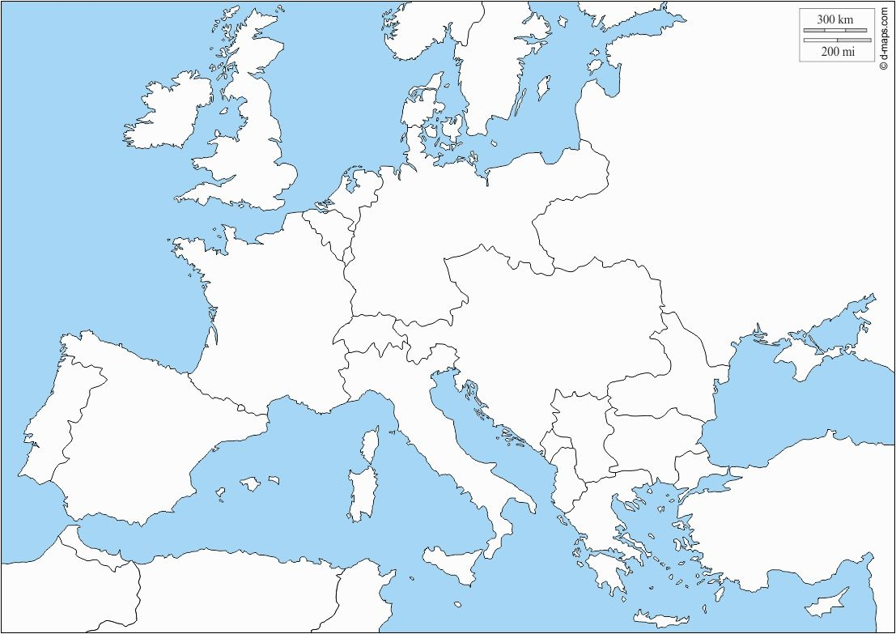
Europe Before WWI
Label the Following (pg. 996)- Great Britain, Ireland, France, Spain, Portugal, Italy, Greece, Albania, Yugoslavia, Turkey, Bulgaria, Romania, Hungary, Austria, Czechoslovakia, Switzerland, Germany, Poland, East Prussia, Lithuania, Latvia, Estonia, Sweden, Denmark. Shade the new countries created after the war in orange.
